Figure 1: Antibacterial activity of TTX extracts of liver, skin and muscles isolated from Puffer fish, L. sceleratus with some gram positive bacteria against Ampicillin (standard).

Figure 2: Antibacterial activity of TTX extracts of liver, skin and muscles isolated from Puffer fish, L. sceleratus with some gram negative bacteria against Gentamycin (standard).

Figure 3: Antifungal activity of TTX extracts of liver, skin and muscles isolated from Puffer fish, L. sceleratus with some fungi strains against fluconazole (standard).

Figure 4: Seasonal TTX levels in different tissues isolated from males of Puffer fish, L. sceleratus (µg/g) using LC/MS/MS.

Figure 5: Seasonal TTX levels in different tissues isolated from females of Puffer fish, L. sceleratus (µg/g) using LC/MS/MS.
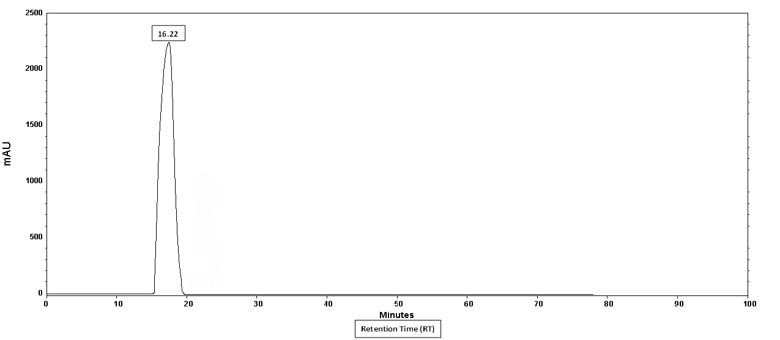
Figure 6: HPLC analysis of TTX in the liver of toxic Puffer fish, Lagocephalus sceleratus from Mediterranean sea, Egypt.
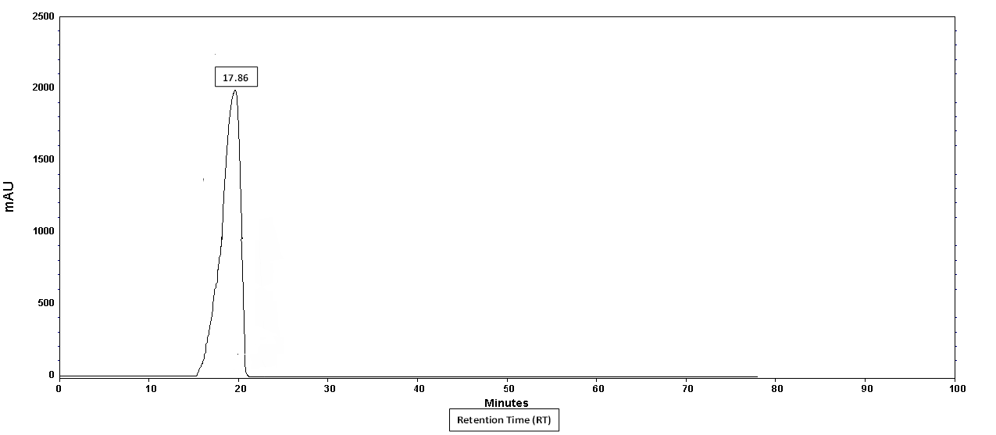
Figure 7: HPLC analysis of TTX standard (Authentic TTX).

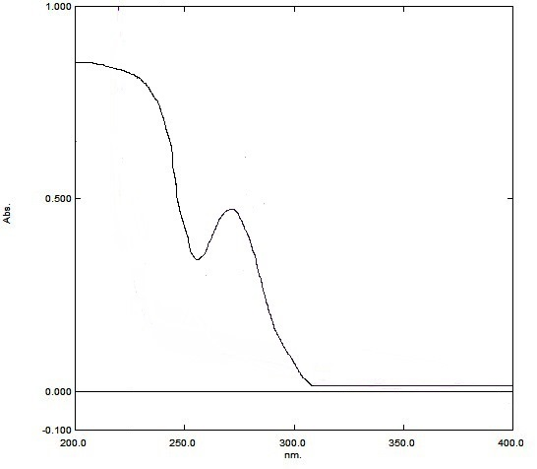
Figure 8: UV absorption spectra of TTX fraction from liver of Puffer fish, Lagocephalus sceleratus inhabiting Mediterranean sea, Egypt.

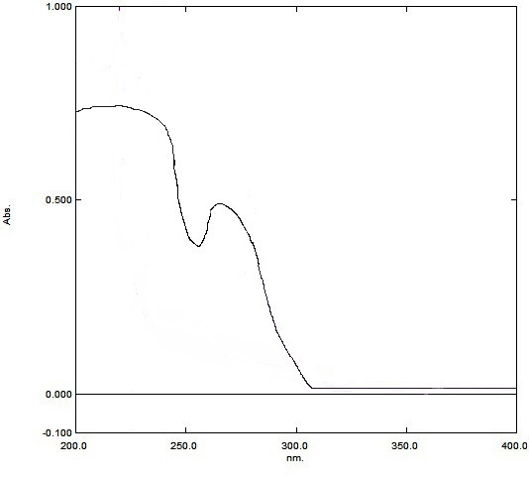
Figure 9: UV absorption spectra of TTX standard (Authentic TTX) fraction.

